Car Accident? Here Are 8 Steps You Should Follow Immediately!
“My back pains are killing me, why didn’t I rush to an Emergency center after the accident?!”
“How do I claim insurance for my car? Obviously I didn’t know anything about photographic evidence!”
Florida is more than often ranked as one of the States in the US with the highest number of road and motor vehicle accidents. For residents of Florida, it only makes sense if they remain aware of the precautions and steps to follow if mighty heavens, an accident occurs!
No matter how cautious you are, accidents are inevitable. So if you do not know already, you can find out what necessary steps you should immediately follow after a road accident in this article. These include steps from a medical, general as well as legal perspective.
8 Steps to Take Immediately After A Road Accident
Provided that you are in your senses after the accident, you should definitely follow these steps to avoid any problems later on.
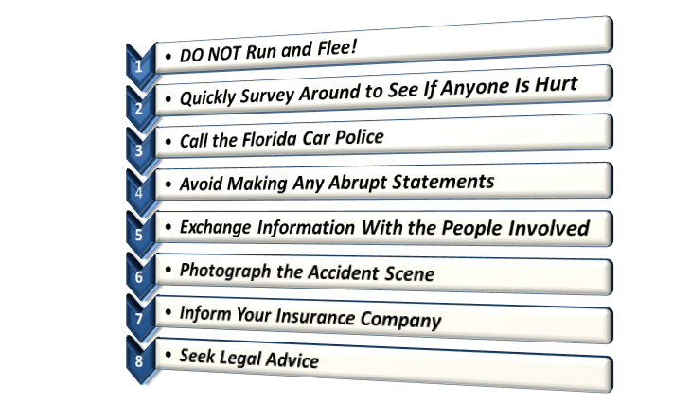
- DO NOT Run and Flee!
Even if it was not your fault that the accident occurred, fleeing the situation would put you off in a bad light and portray you as a criminal.
Rushing in such a scene even if you have not sustained any injuries is not a sensible thing to do. Rushing now would only result in ill fate on you later in the form of legal action.
- Quickly Survey Around to See If Anyone Is Hurt
Depending on the accident, major or minor injuries can be sustained. You need to quickly check who was involved in the accident and call 911 if someone has been seriously hurt. This needs to be done on an instant basis to avoid any fatalities.
- Call the Florida Car Police
It is extremely important that the concerned Area Police is notified regarding any road accident that occurs. The police will secure the accident scene, note down all the details and accordingly produce an official Accident Report.
The Accident Report acts as the ultimate piece of evidence for litigation purposes later on. Therefore, make sure that the Police is present straightaway after the accident.
Do not forget to get a copy of the report either, and note down the names of the officers who were on duty to get a copy later on.
- Avoid Making Any Abrupt Statements
It is understandable that you would be compelled towards apologizing after an accident; however you need to refrain from quickly pleading “I’m sorry that was totally my fault!”
Such statements can lead to an Admission of Fault, where the blame of the accident will immediately be shifted over you in record. Instead, deal with the matter on a clear-headed scale and speak without haste.
- Exchange Information With the People Involved
While you need to keep your interactions on a minimum to avoid making any statements, you do need to extract information from all the people who were involved in the accident. This includes the driver with whom you probably collided and the pedestrians nearby.
You can ask for information such their names, addresses and phone numbers. This is necessary because their insight on the accident can prove to be useful for being included in the Accident Report.
- Photograph the Accident Scene
Pictures and images are often the most valuable piece of evidence especially in matters of litigation or claiming insurance. You can use your smartphone to photograph the scene, and even record a brief video of the scene.
- Inform Your Insurance Company
In order to claim your respective insurance, it is necessary that you inform your Insurance Company right away. While this may appear as off-setting, you will be required to answer a lot of questions by the Insurance agent. However, this is essential so that you can claim your Insurance without hurdles.
- Seek Legal Advice
In cases where major or serious injuries were involved, you should not hesitate in soliciting legal counsel. Before you are subject to legal action yourself, it is better if you sought legal counsel and prepared yourself for the necessary legal proceedings.

